**Project Design Phase-II**

**Data Flow Diagram & User Stories**

|  |  |
| --- | --- |
| Date | 26 June 2025 |
| Team ID | LTVIP2025TMID53123 |
| Project Name | ResolveNow: Your Platform for Online  Complaints |
| Maximum Marks | 4 Marks |

Data Flow Diagrams (DFD) – ResolveNow

A Data Flow Diagram (DFD) is a visual representation of how data moves through the ResolveNow complaint registration and management system. It outlines how data enters the system, how it is processed, where it is stored, and how it exits the system. The DFD helps in understanding system functionalities and the flow of information between users, processes, and databases.In the context of ResolveNow, the DFD shows how complaints are registered by users, assigned by admins, resolved by agents, and tracked throughout their lifecycle.

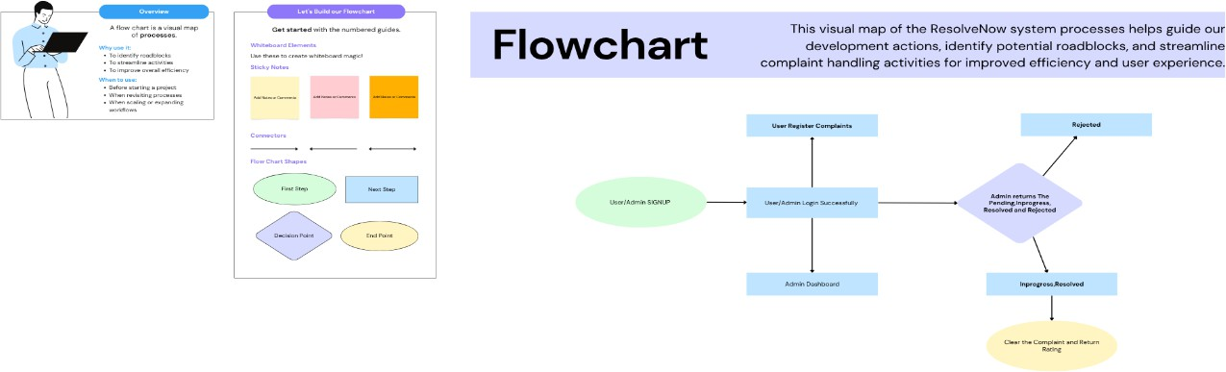

**USER STORIES – RESOLVENOW**

|  |  |  |  |  |  |  |
| --- | --- | --- | --- | --- | --- | --- |
| **User Type** | **Functional Requirement (Epic)** | **User Story Number** | **User Story / Task** | **Acceptance Criteria** | **Priority** | **Release** |
| **Customer (Mobile user)** | Registration | USN-1 | As a user, I can register for the application by entering my email, password, and confirming my password. | I can access my account/dashboard after registering | High | Sprint- 1 |
|  |  | USN-2 | As a user, I will receive a confirmation email once I have registered. | I can receive a confirmation email and verify my account | High | Sprint- 1 |
|  |  | USN-3 | As a user, I can register using Facebook login. | I can register and access the dashboard using Facebook | Low | Sprint- 2 |
|  |  | USN-4 | As a user, I can register using my Gmail account. | I can sign up and reach the dashboard using Gmail | Medium | Sprint- 1 |
|  | Login | USN-5 | As a user, I can log in using my registered email and password. | I can successfully log in and view my dashboard | High | Sprint- 1 |
|  | Complaint Submission | USN-6 | As a user, I can submit a complaint by filling in the form. | Complaint is submitted and confirmation is shown | High | Sprint- 1 |
|  | Complaint Tracking | USN-7 | As a user, I can track the status of my complaints. | I can view complaint status updates on my dashboard | High | Sprint- 1 |
|  | Chat with Agent | USN-8 | As a user, I can chat with the assigned agent. | I can send and receive messages with the agent | High | Sprint- 2 |

|  |  |  |  |  |  |  |
| --- | --- | --- | --- | --- | --- | --- |
| **User Type** | **Functional Requirement (Epic)** | **User Story Number** | **User Story / Task** | **Acceptance Criteria** | **Priority** | **Release** |
|  | Feedback | USN-9 | As a user, I can submit feedback after complaint resolution. | I can submit a star rating and comments | Medium | Sprint- 3 |

|  |  |  |  |  |  |  |  |  |  |
| --- | --- | --- | --- | --- | --- | --- | --- | --- | --- |
| **Customer (Web user)** | | Registration/Login | | USN-10 | As a web user, I can register and log in through the web portal. | | Account is created and dashboard is accessible | High | Sprint- 1 |
|  |  | Complaint Submission | | USN-11 | As a web user, I can submit complaints via the web form. | | Complaint is saved and visible in “My Complaints” | High | Sprint- 1 |
|  |  | View Status | | USN-12 | As a web user, I can check complaint resolution status. | | Updated status is shown in the user’s dashboard |  |  |
| **Customer Care Executive** | View Assigned Complaints | | USN-13 | As an agent, I can view the list of complaints assigned to me. | The assigned complaints are listed on my dashboard. | High | Sprint-1 |  |  |
|  | Complaint Status Update | | USN-14 | As an agent, I can update the status of a complaint (e.g., Pending, In Progress, Resolved). | The updated status is reflected on the user's dashboard. | High | Sprint-2 |  |  |
|  | User Communication | | USN-15 | As an agent, I can chat with  users assigned to my complaints. | Messages are  exchanged in real- time via chat. | High | Sprint-2 |  |  |

|  |  |  |  |  |  |
| --- | --- | --- | --- | --- | --- |
| Complaint Details View | USN-16 | As an agent, I can view full complaint details submitted by the user. | I can see all fields and attachments of the complaint. | High | Sprint-1 |
| Close Complaint | USN-17 | As an agent, I can mark a complaint as resolved. | Status changes to  "Resolved" and user is notified. | Medium | Sprint-2 |

|  |  |  |  |  |  |  |
| --- | --- | --- | --- | --- | --- | --- |
| **User Type** | **Functional Requirement (Epic)** | **User Story Number** | **User Story / Task** | **Acceptance Criteria** | **Priority** | **Release** |
| **Administrator** | Manage Complaints | USN-18 | As an admin, I can view all complaints submitted by users. | Complaints are listed with filters and full details. | High | Sprint- 1 |
|  | Assign Complaints | USN-19 | As an admin, I can assign complaints to agents based on category or workload. | Complaint appears in the assigned agent's dashboard. | High | Sprint- 1 |
|  | Manage Users | USN-20 | As an admin, I can view, edit, or delete user and agent accounts. | Admin has full access to manage accounts. | High | Sprint- 2 |
|  | View Reports | USN-21 | As an admin, I can generate reports on complaints and performance. | Reports show complaint stats, agent activity, and feedback. | Medium | Sprint- 3 |
|  | System Settings | USN-22 | As an admin, I can configure platform settings and complaint categories. | Changes reflect in user interfaces where applicable. | Medium | Sprint- 3 |
|  | View Feedback | USN-23 | As an admin, I can view feedback submitted by users after resolution. | Ratings and comments are visible with complaint IDs. |  |  |